How to Design a Bridge https://www.garrettsbridges.com/design-it/


- Design It
- Build It
- Break It
- Examples

- Kits and Plans

How to Design Your Model Bridge from Start to Finish
This is a complete guide to help you design a strong model bridge.
These are the same design principles that I use when building model bridges.
In this section, you will learn the basics of bridge design and how engineers use these ideas in real life bridges. You will learn about the history of bridges and some of the important figures who helped invent new ideas and designs. You will learn how to get the most out of your bridge given your specific design guidelines and restrictions.
Let’s jump in.

Preparation is Key
Have you ever heard the phrase, “measure twice and cut once”? This definitely applies to designing a model bridge. I draw attention to this because I know it can be easy to miss important parts of the rules and end up with a bridge that doesn’t work. Don’t ask me how I know this…

Define the Goal
Start the process by clearly defining what your bridge is trying to do. This gets you into the right frame of mind. Here are some example goals:
- To build a bridge that is 1 meter long and can hold 50kg without breaking.
- To build the lightest bridge that spans 12 inches that can hold at least 12 textbooks.
Your goal might be given to you by a teacher, coach, or through written instructions. But you still need a goal if you are building a bridge on your own. Create a challenge for yourself. Try to do something you don’t think is possible at the moment. You will probably be surprised at how well little bridges do when designed and built well.
A clear understanding of the goal is very important before you get any further. It will help keep you on track to creating a successful bridge. Also, bridge design can change a lot based on your goals, as we will look at later. Keep these goals front and center in your mind!
Closely tied to the goals are your rules/restrictions; the guidelines under which you must meet your goal.

Understand the Rules
Just as important as defining your goal is clearly defining your guidelines/rules. You don’t want to get disqualified or a get low grade by simply not following the instructions. Sometimes even a small detail can make all the difference.
I remember making a Balsa wood tower for a competition many years ago. I had spent a lot of time building it, and was really excited to bring it to the competition. However, the night before I realized I had misread a key detail in the rulebook, and my tower was 2cm too short.
This was gut wrenching.
I was able to make a last minute repair, but it was not ideal. This could have been avoided if I had read the rules a little more carefully.
It is very important to make sure you understand all the rules your bridge must follow before you actually start building. A good way to do this is to be able to say the rules in your own words, seeing (in your mind) what they mean.
This idea is true of real life engineering. Engineers spend time understanding the area in which the bridge will be built. They want to know how much traffic will cross the bridge, and if this traffic is small cars or big trucks. Do boats need to pass underneath the bridge, and if so, how tall are these boats? Is the bridge in an area known for having earthquakes? Often a key restriction is the budget, which will determine the materials and construction methods they can use.
An engineer is simply a problem solver. A bridge, therefore, is just a way to solve the problem: how to get from here to there? The solution is made complicated by the any restrictions as talked about above. Social and political demands can also play a part, as well as what materials are around to use.
Your job as a model bridge builder is easier than building a bridge over a river, but the same ideas apply.
Some of the things you want to pay extra attention to are minimum and maximum dimensions, materials allowed, and how the bridge is to be loaded.
Here are some examples of basic restrictions:
- To build a bridge that is 1 meter long and can hold 50kg without breaking using just 200, unmodified popsicle sticks and Elmer’s White Glue.
- To build the lightest bridge that spans 12 inches that can hold at least 12 textbooks with balsa wood, string, and glue.
I’d almost go so far as to say to memorize your guidelines or rules. It really helps a lot to have these in the back of your mind as you continue on building the bridge.
Ask yourself these questions:
- How long, wide, and tall does my bridge need to be?
- Where is my bridge going to be loaded?
- Do I have to allow traffic across (a hotwheels car for example)?
- Am I limited in what materials (wood, glue, etc) I can use?
Generally speaking, do not make your bridge larger in any direction than it needs to be to support itself. If you have to span 12 inches, don’t make your bridge 15 inches long. That is too much extra. Instead, max out at 13 inches. 1/2 inch on each side will be plenty to support the bridge. Any more will simply add extra weight without providing more strength, which will reduce the efficiency of the bridge.
The point (or points) where your bridge will be loaded is a key detail which will affect how you design the bridge. Since the purpose of a bridge design is simply to transfer the load from the loading point to the ground, the structure of the bridge can change significantly depending on this one detail. Is your bridge loaded from the top or the bottom? Are you using a bucket full of sand, placing weights or books on top of the bridge, or trying to stand on the bridge yourself?
Once you have defined and understand the goals and restrictions, you are ready to go on. Next up is the fun stuff, bridge types and truss designs.

Bridge Design Ideas
Bridge design is a big topic. I’ve decided to break it down into smaller sections and will send you to several other pages on my website. Here is an intro:

Types of Bridges and Designs
The first thing you need to know are the different types of bridges, including:
- Beam
- Arch
- Truss
- Cantilever
- Suspension/Cable Stayed
Learn about the basics for each of the bridge types listed above.
Each of these types of bridges has its place in both real and model bridge building. I’ve listed them from easiest to hardest. A beam bridge is the simplest to create while a suspension bridge has a lot more parts to it.
I’ve highlighted truss bridges because these are super common in model bridge building, and I spend a lot more time focusing on these. Chances are you will be building a truss bridge.
Within the truss bridge category, there are a lot of different designs that have been used over the years to make real bridges. A few of these are common in model bridges, including the Warren, Pratt, and Howe designs. I’ve written another set of articles explaining each one that you should check out.
Dive deep into Truss Bridges.
What are the forces that act on a bridge?

Free Bridge Design Software
You can download a free program called the Bridge Designer which allows you to create a bridge and see how it responds to a truck driving over it. The goal of the program is to design the cheapest bridge for any given situation, and you can choose from several different materials. I have spent a lot of time using this program, and not only is it fun, it is very helpful in learning how bridges work.
I highly recommend you check out the Examples on my website to see what other ideas have been tried and what you can learn from them.

Customize Your Design to Your Scenario
By now you have learned more about the bridge types, and a lot about truss design. If you haven’t, go back and check out those two sections mentioned above.
Now we will take that knowledge about design and apply it to common model bridge situations.
But first, let me say that I grew up participating in the National Science Olympiad structure competitions. In fact, this is how my love of bridges started. If your school has a Science Olympiad team, I would highly recommend checking it out.
Sometimes, in this competition, we learned not to use common bridge designs. In fact, our designs started looking nothing like traditional bridges. Our goal was often to build the lightest bridge that could hold a specified amount of weight. This goal, combined with the given rules, got us thinking outside the box. We custom designed every part of the bridge to exactly fit how the bridge was going to be loaded.
This type of thinking will help you problem solve like an engineer.
How can you put these ideas into use?
Simply put, your model bridge has to to transfer the load, from wherever it must be supported from, through your bridge and eventually onto solid ground (or the table) that the bridge sits on. Most commonly, the load is centered over a gap. That is the scenario we will run with here. If yours is different, you will need to use your problem solving skills to transfer the concepts.
Take a look at this diagram. You can clearly see there is a span over which the force must be supported. On the left, the force is higher than the supports, and on the right the force is even with the supports.
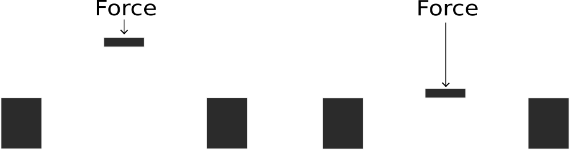
Now, in this next diagram, you see two typical bridge designs (the Warren truss).
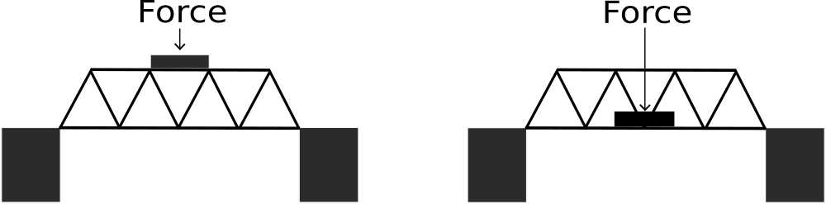
The Warren truss uses solid engineering to transfer the force to the supports in both cases. Again, make sure you check out the Truss Design page to understand how it does this.
Now, in this third diagram, you see two non-standard designs which have been customized to fit this unique situation.
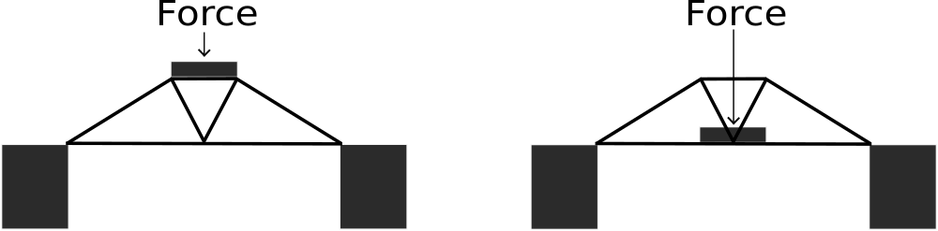
These last two examples most likely does not look like a bridge you have seen in real life. This is because it probably wouldn’t work in real life, as a real bridge must support a moving force instead of one concentrated force. However, we can use this simplicity in loading model bridges to our advantage when you want to push the envelope of efficiency.
Because these two bridges are designed in such a specific manner to meet the loading requirements stated in their rulebook, they have a good chance of out-preforming the Warren truss examples above, if all else was equal and they are built well.
My challenge for you is to think about the simplest way to transfer your load to the ground. Don’t think in terms of a “bridge”, but think outside the box. Sometimes the best/simplest way is by using a standard truss design. But in some cases you can leverage simplicity to your advantage.

Truss Design Simulator
Another free resource that will be very valuable to you is the Johns Hopkins Truss Simulator. This will help you see just how the forces are spread out on your design, and you can start to get an idea of how much force is on each part (member) of your bridge design.
You are almost ready to take all these ideas and come up with a design for your model bridge. But I want to touch on a couple last points before you start.

Finishing Touches to Your Design Plan

Materials and Joints
You should have already defined or figured out what materials you can use. However, often there is still room for you to make some decisions about your materials. If so, here are some things to think about. To see all my articles about materials, see this page.
Most model bridges are made from wood, so here is a quick summary.
Wood is amazing. It has been used in bridge building for a very long time and is a standard for model bridges. Balsa and Basswood, popsicle sticks, and paper are pretty common choices. When you are designing your bridge keep these things in mind:
- Wood, (materials in general), is strongest when loaded in its widest dimension (Link 1 Link 2)
- Balsa wood takes care to use. Learn how to choose the best Balsa wood.
- Wood grain plays a part in joint strength
- Often the weakest part of a wood bridge is the joints
There are four main types of joints that we use with model bridges, and you can read more about each on my Bridge Joints page.
- Lap Joint
- Butt Joint
- Notched Joint
- Gusset
I’m a huge fan of using lap joints or butt joints with gussets. Knowing the type of joint you will use for your bridge (or types, you can mix and match), will help you with drawing your bridge design out.

Draw Your Bridge to Scale
The next step is to draw your design out on paper. In a perfect world, you will make a full size drawing. This will make it much easier to build the bridge.
But before you can draw your bridge, you must decide how big each piece (member) of your bridge will be. I’ll give you a good starting place, but I really encourage you to make a few bridges so that you can test each one, learn, and improve each time. When you do that, you really start to learn.
If you have no idea where to start with the sizing of your wood, start with 1/4″x 1/8″ pieces. This is on the large size for most model bridges, but it this size is easy to work with and will allow you to gain experience with glue and assembly.
Or, if you have access to a CAD program, you could plug the design in and print it from there. I’ve found having that scale drawing to be very helpful in making sure there are no surprises when you start building, which you are almost ready to do.
If you are building more than one bridge, I suggest that you make sure to label and date your drawings.
Graph paper works best, and you can tape two or more sheets together if you have a long bridge. I would make drawings from three angles: from the side, the top, and portal (as if you are looking through the bridge). You can also draw from the bottom angle, but I find this less important as often the bottom is super simple in construction.
That’s it for this overview of Model Bridge Design. You can view more articles in this section on the right menu and move on to Step 2 when you are ready.

Step 2: Building your Bridge

Bridge Plans and Kits
I have created several ready to go designs using popsicle sticks that are available in my store. You can get just the digital plans, or I can send you a complete kit with all the materials needed for building.
Check out these plans and kits

